**Hayward RPP Weekly Update 13th June 2024**

Spike length:

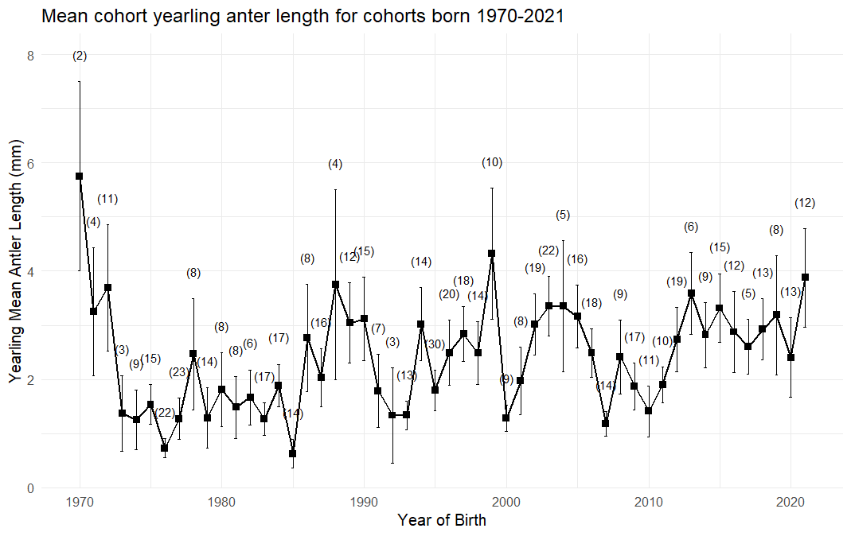

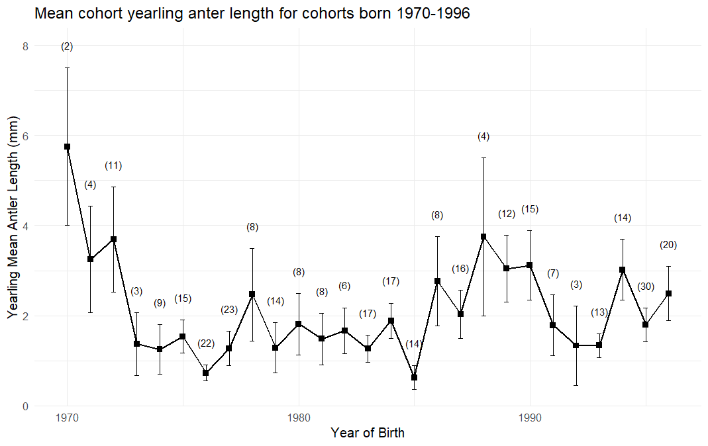

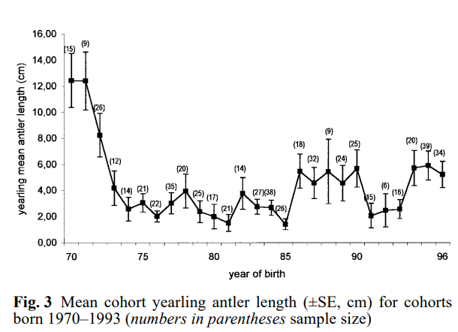

Schmidt, K. T., Stien, A., Albon, S. D., & Guinness, F. E. (2001). Antler length of yearling red deer is determined by population density, weather and early life-history. *Oecologia*, *127*, 191-197.

The previous study (Schmidt et al 2001) used deer aged 16 months old. Month data were not available in a lot of the observations so I couldn’t replicate it. The trend of my data is similar to the one from the previous study, sample size is smaller (323 vs 518) and my spike lengths seem to be smaller especially for early 1970s.

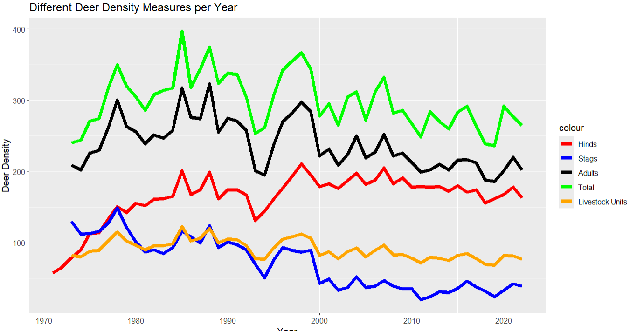

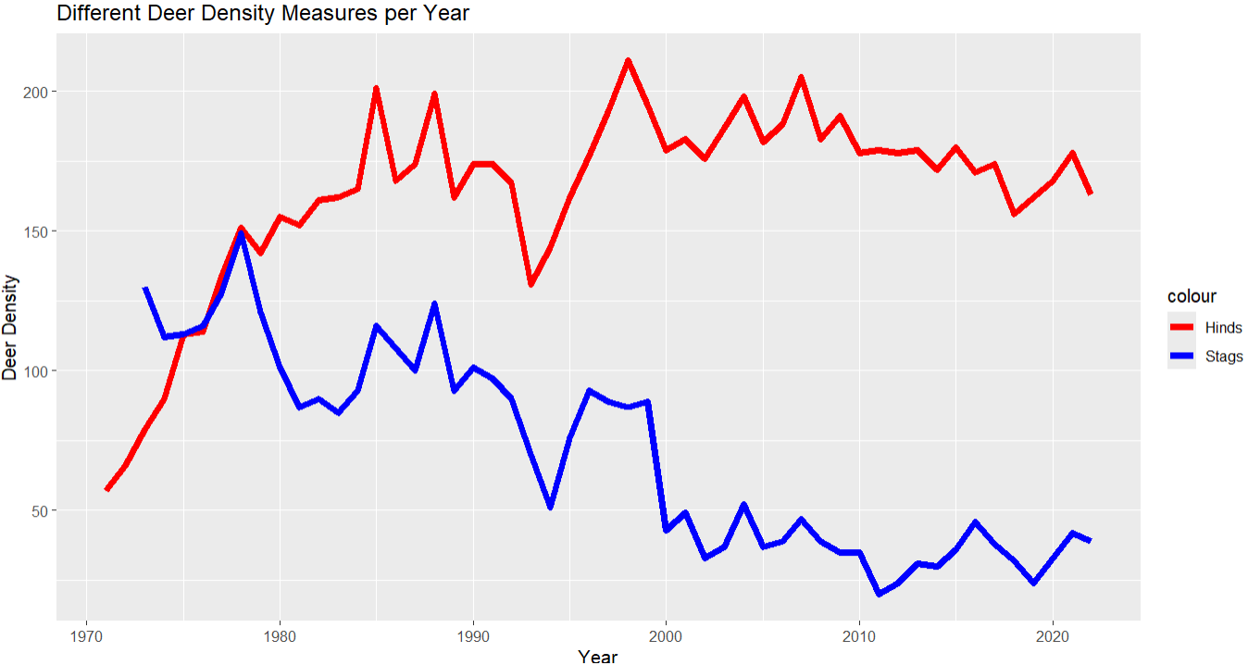

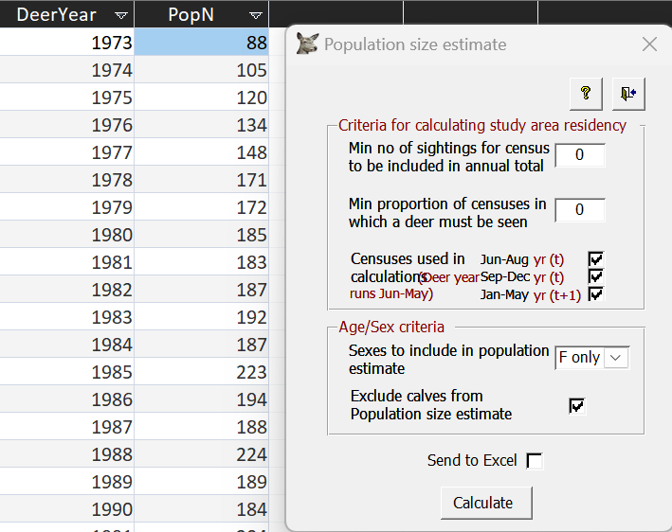

Moreover, using the built in query for density (pop est), I was unable to retrieve any density data for 1970,71,72, it always starts in 1973, no matter how I change the parameters.

Missing those initial years with the longest spike length meant the biggest drop in spike length was not captured in my models.

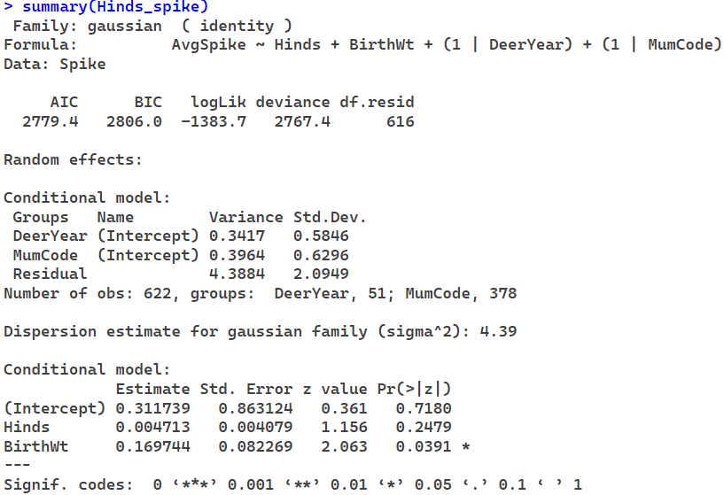

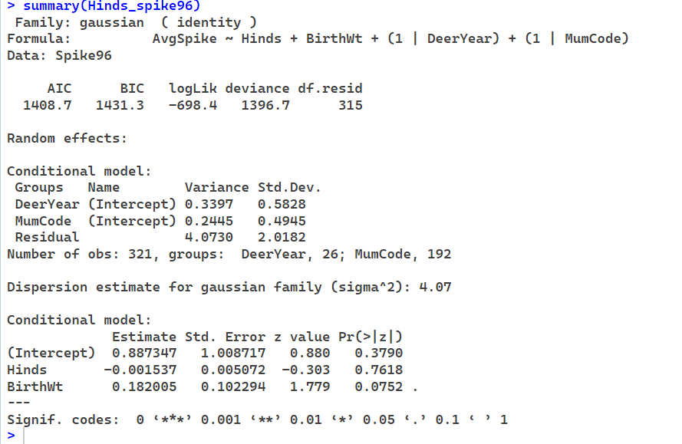

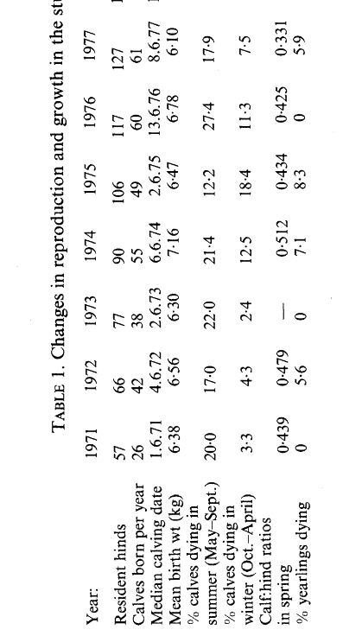

Clutton-Brock, T. H., Albon, S. D., & Guinness, F. E. (1987). Interactions between population density and maternal characteristics affecting fecundity and juvenile survival in red deer. *The Journal of Animal Ecology*, 857-871.

I tried using 1971 & 1972 hind density I found from (Clutton-Brock et al 1987) for my model, however the density from later years are slightly different from my own data set.

With the 71&72 density plugged in, the models from 1971 to 1996 showed a decrease in spike length now, but it's not significant.

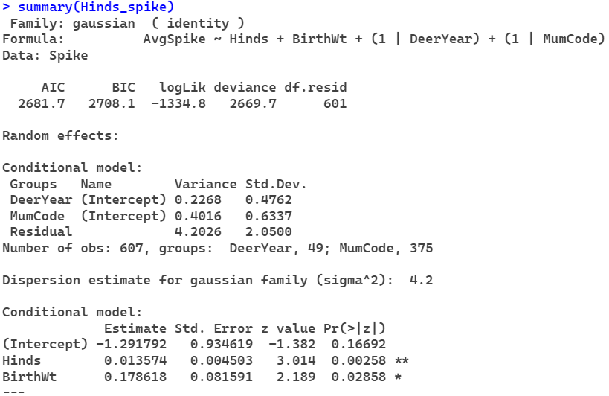

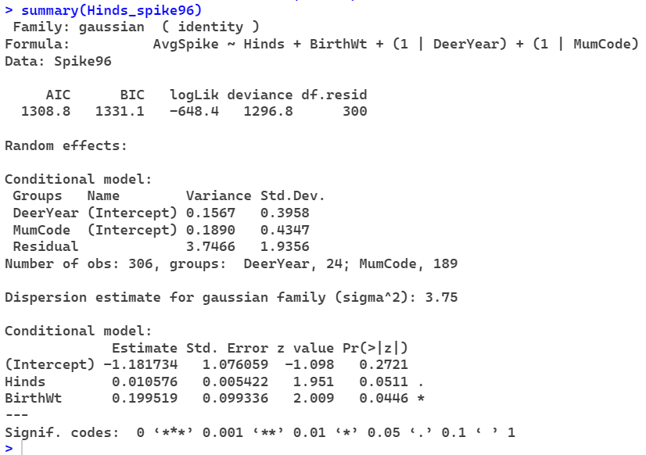

When I include an additional year as a continuous fixed effect, the year becomes significant but now none of the density measures is significant, not even hinds.

Fecundity: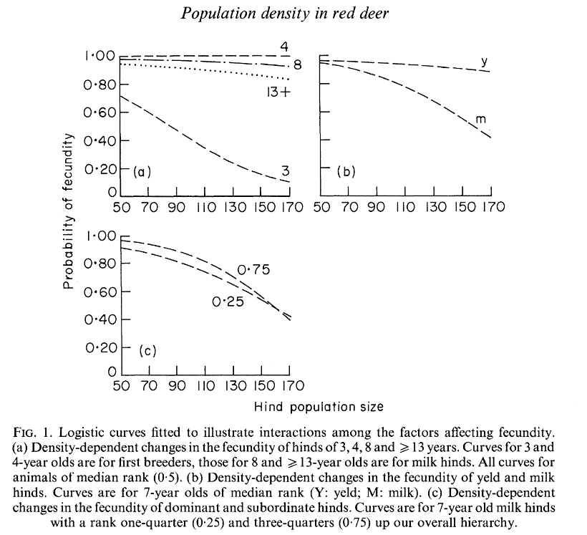

(Clutton-Brock et al 1987)

For my initial models that included age, and age squared they were always very significant. So I only kept data where the Hind is 3 years or older, but they still have a really small p value <2e-16.

Reproductive status also has p values of <2e-16, but I did not receive any error messages this time so I’m not entirely sure if the model is working.

When I did separate my data based on reproductive status, having milk females, naive females and all the yeld females in 3 separate groups, I found that milk females are more susceptible than yeld females like Fig 1 B above (Clutton-Brock et al 1987) suggested. Although both yeld and naive were insignificant.

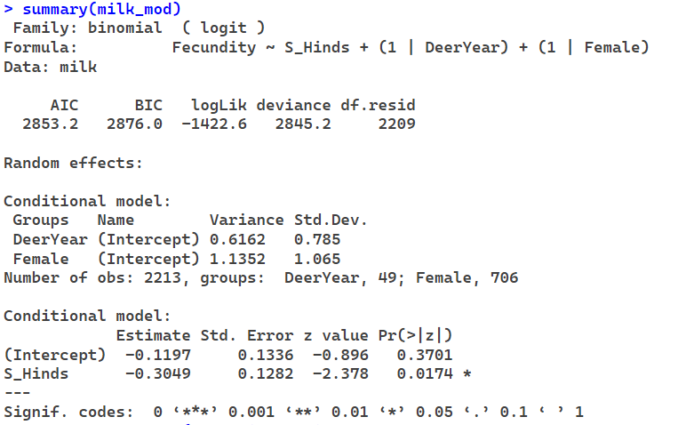

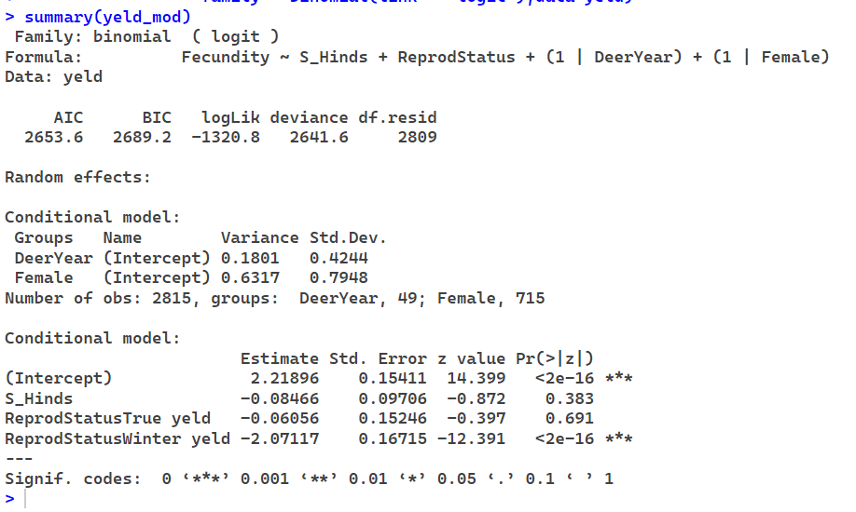

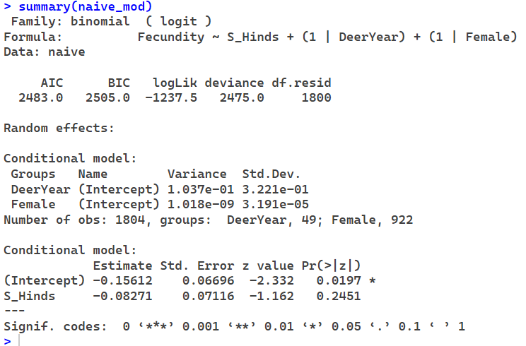

For the normal models with all the reproductive status, hind density is once again the only density measure that is significant, and reproductive status from the previous year is a much better predictor than density. I wonder if there’s anyway for me to improve the model as my AIC value for these models are extremely high.

